**Practical No. 5**

**Aim: User Management in Cloud .**

**Theory**: User management describes the ability for administrators to manage user access to various IT resources like systems, devices, applications, storage systems, networks, SaaS services, and more.

• User management is a core part to any directory service and is a basic security essential for any organization.

• User management enables admins to control user access and on-board and off-board users to and from IT resources.

• Subsequently a directory service will then authenticate, authorize, and audit user access to IT resources based on what the IT admin had dictated.

• Traditionally, user management has been grounded with on-prem servers, databases, and closed virtual private networks (VPN). However, recent trends are seeing a shift towards cloud-based identity and access management (IAM), granting administrators even greater control over digital assets.

User management allows administrators to manage resources and organize users according to their needs and roles while maintaining the security of IT systems. Administrators need powerful user management capabilities that can allow them to group users and define flexible access policies.

For end-users, many parts of user management are invisible. When users are exposed to user management—for example, when they use a login box to access an application—they expect the interaction to be simple and seamless. Login is a frequently-performed, critical operation, meaning that any delay or malfunction annoys users and hurts productivity.Many organizations recognize that on-premise IdP solutions are insufficient for the modern IT environment. Users increasingly rely on cloud services and access corporate systems remotely, often via personal devices, and traditional IdP cannot address these use cases.

Organizations must find a way to manage secure access for a distributed environment. At the same time, users demand the same simplicity of popular services like Google and Facebook in their work environment. These challenges are making user management more important and more complex than ever before.

**Methods and Steps:**

1. OwnCloud(local)

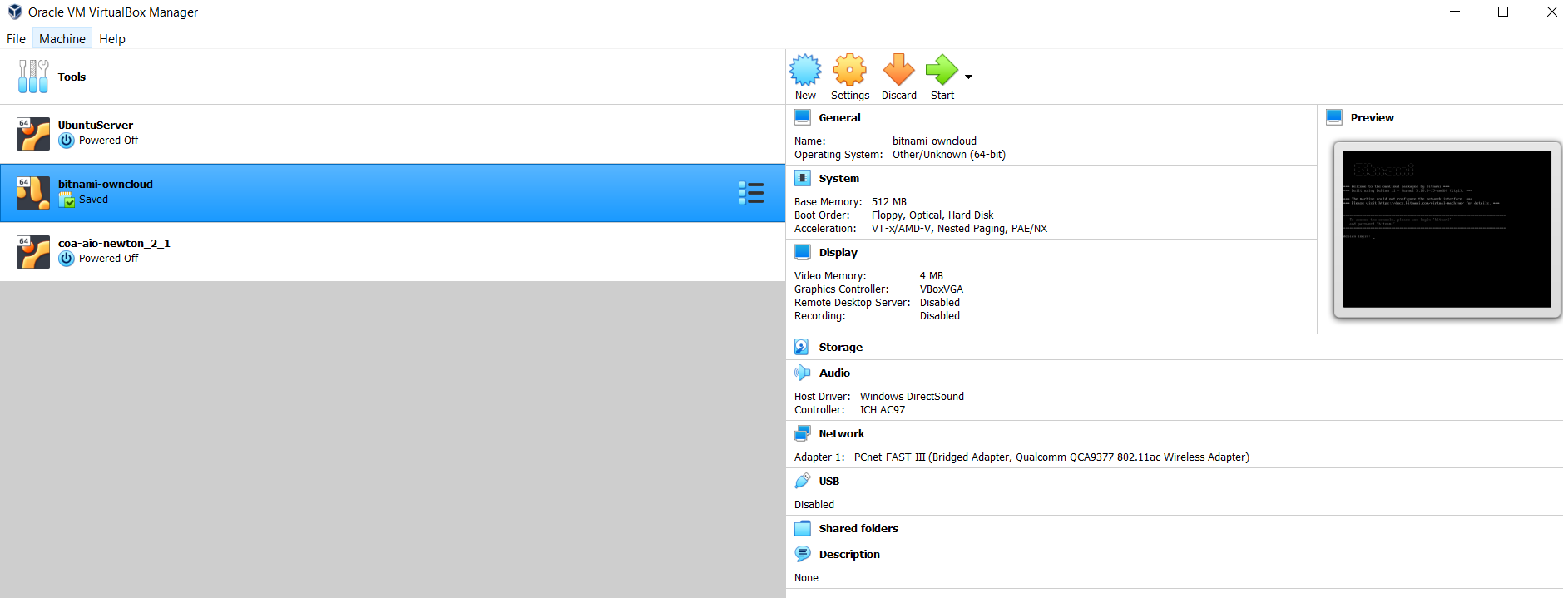

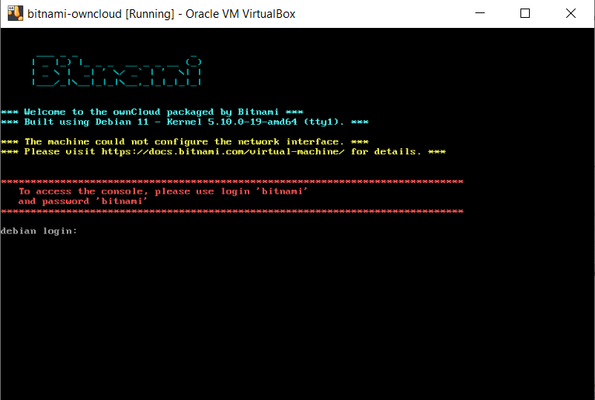

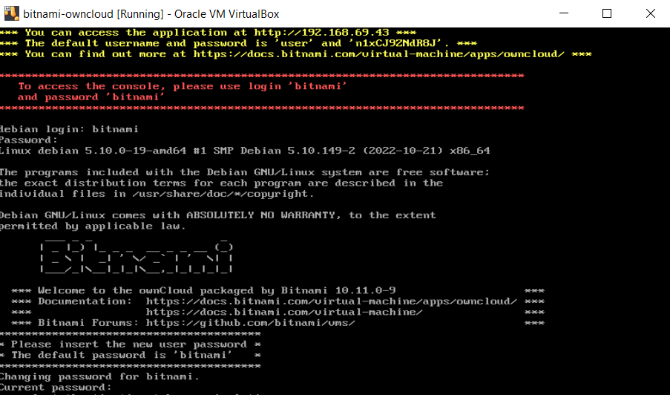



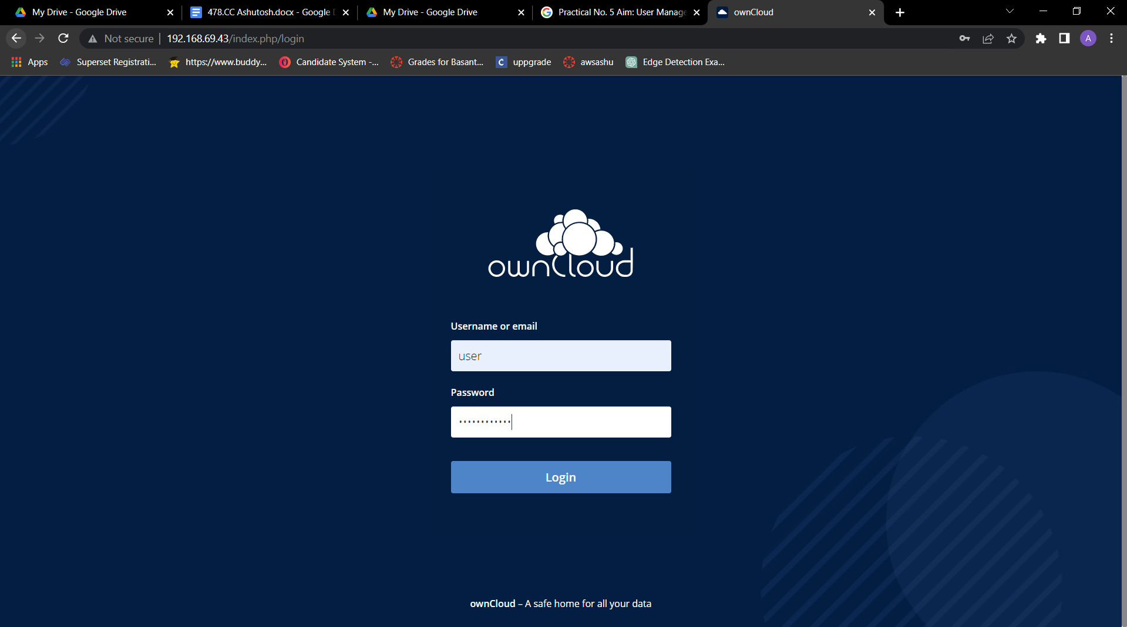

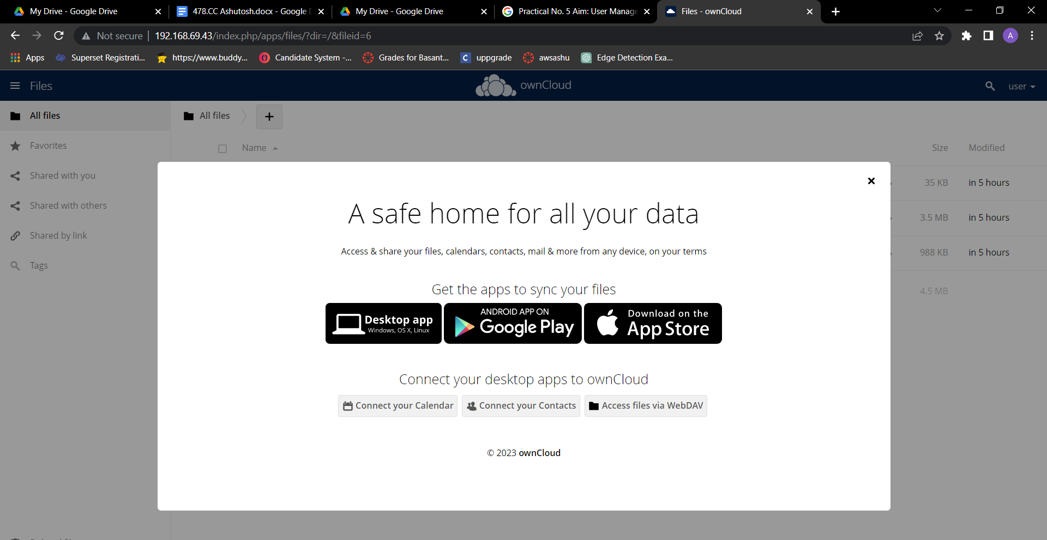

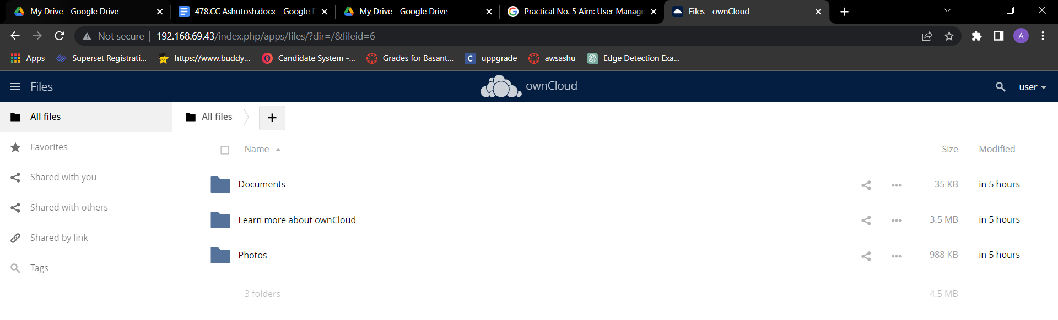

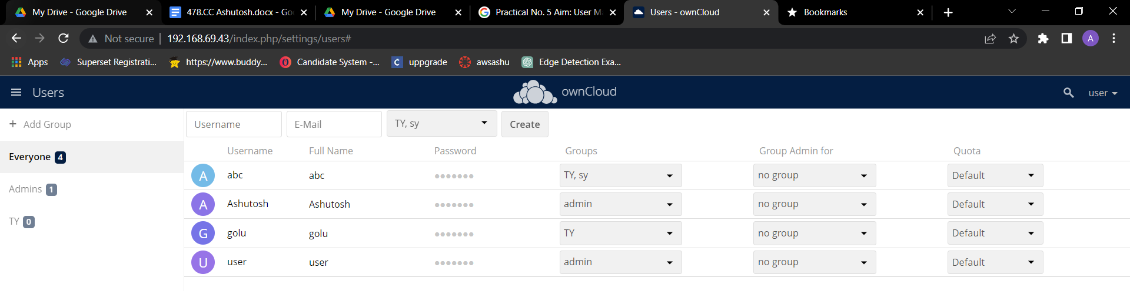

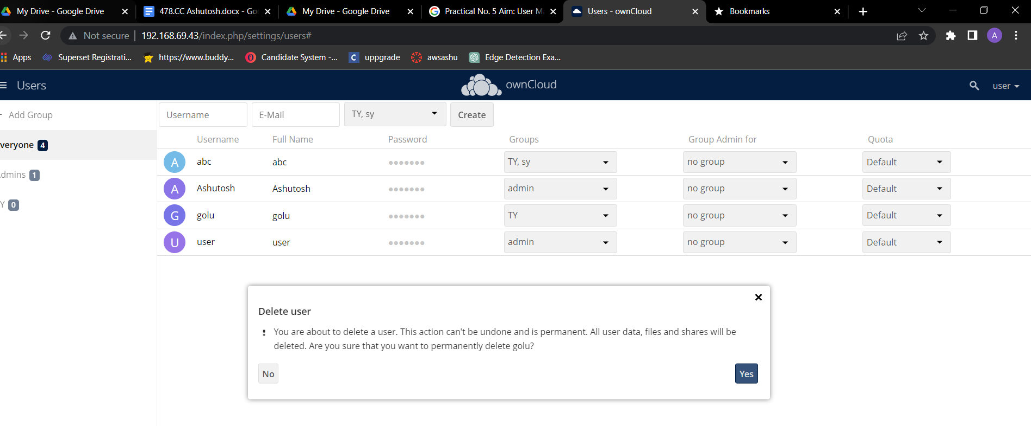

DELETE USER GOLU:

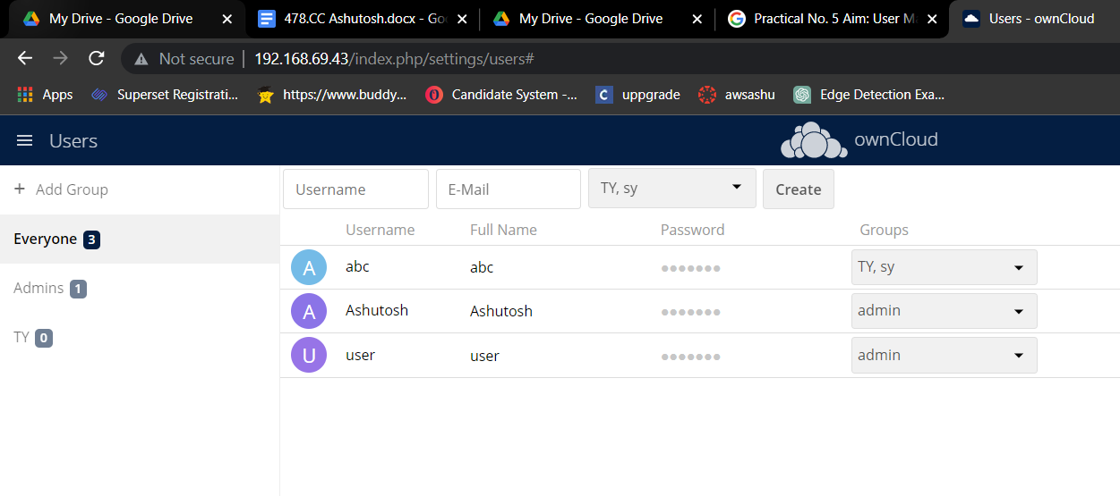

USERS :

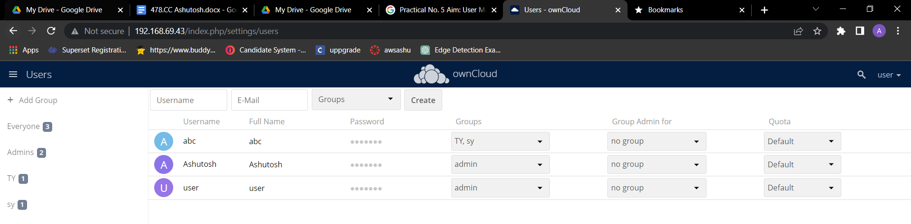

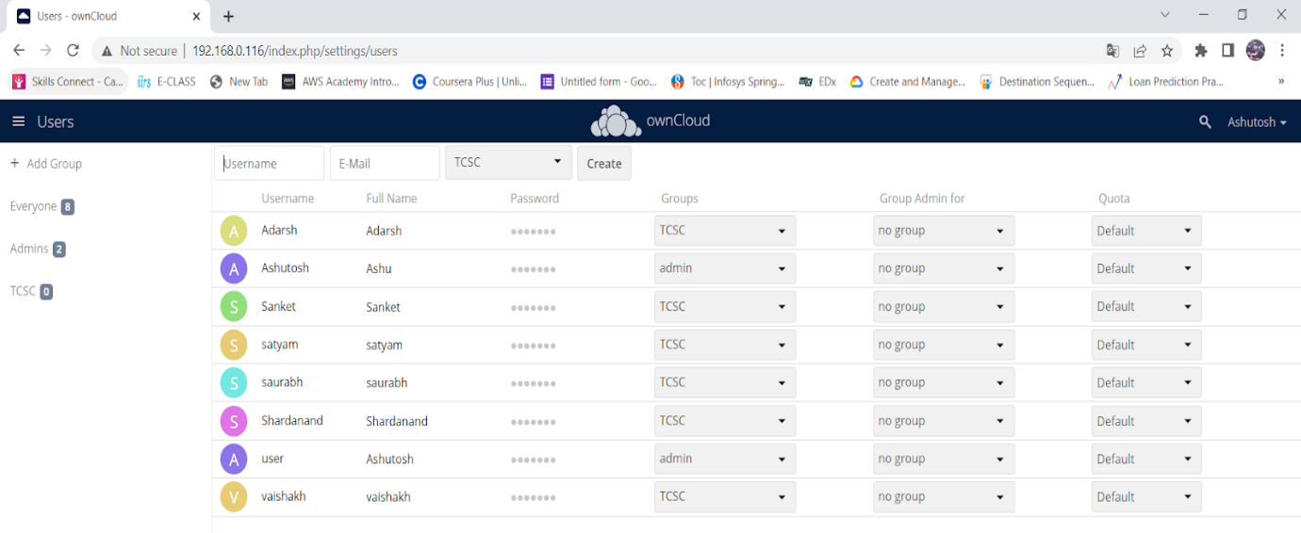 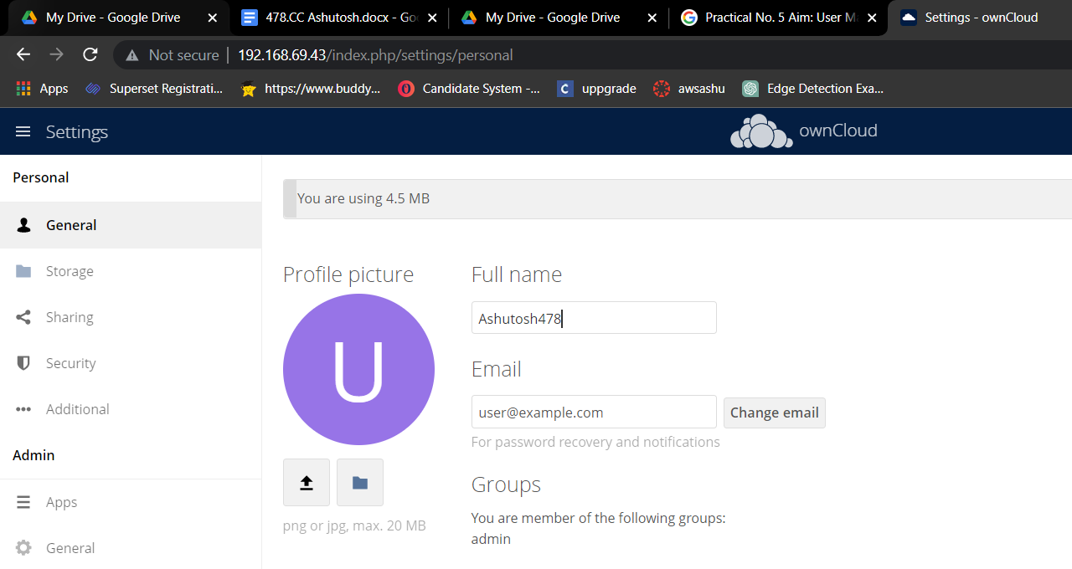

**CONCLUSION :** Successfully Performed User Management in Cloud…..